**Login for standard user**

Step 1: Navigate to swag labs site using the URL- <https://www.saucedemo.com/>

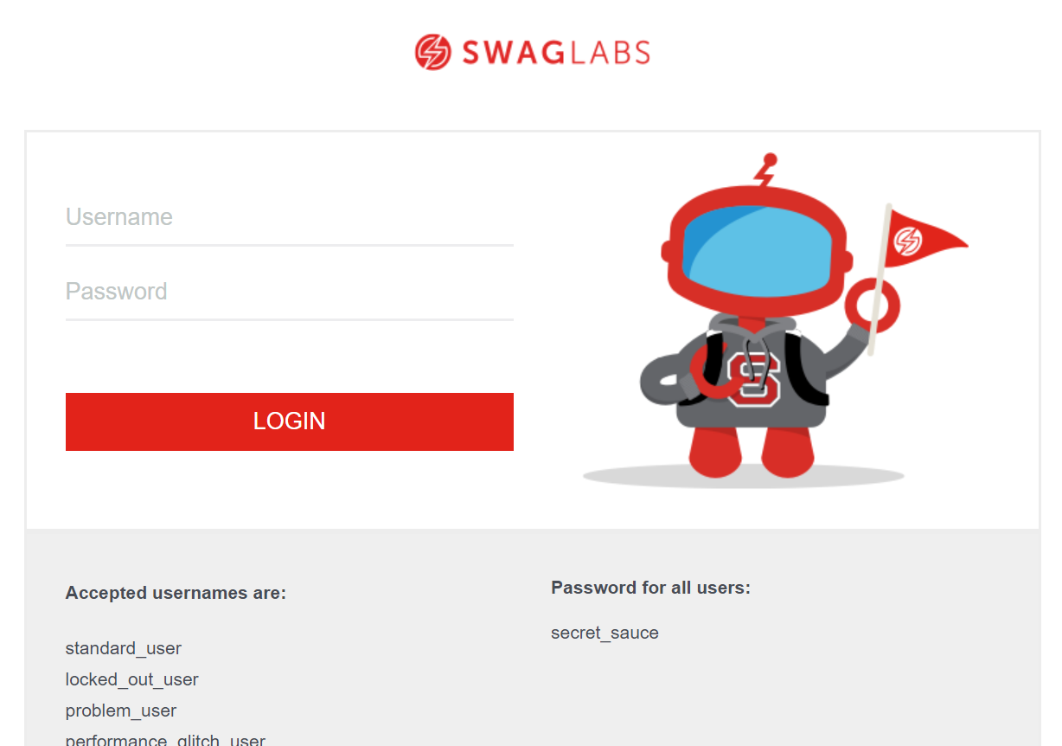

Step 2: Provide username, Given: Username= standard_user

Step 3: Provide password, Given: Password= secret_sauce

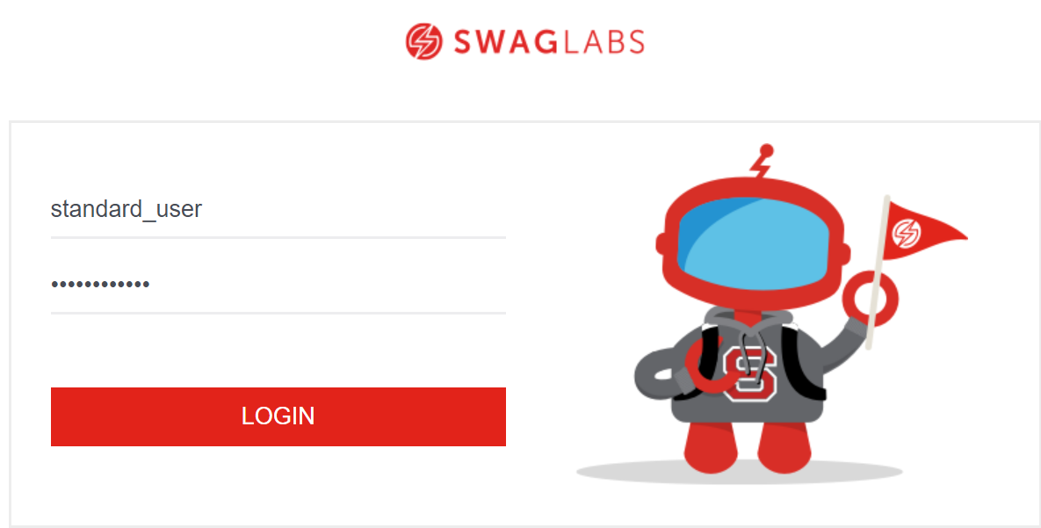

Step 4: Click on login button and user should be able to login.

